What is Java?

Java is a **programming language** and a **platform**. Java is a high level, robust, object-oriented and secure programming language.

Java was developed by *Sun Microsystems* (which is now the subsidiary of Oracle) in the year 1995. *James Gosling* is known as the father of Java. Before Java, its name was *Oak*. Since Oak was already a registered company, so James Gosling and his team changed the name from Oak to Java.

**Simple.java**

**class** Simple{

**public** **static** **void** main(String args[]){

     System.out.println("Hello Java");

    }

}

## Application

According to Sun, 3 billion devices run Java. There are many devices where Java is currently used. Some of them are as follows:

1. Desktop Applications such as acrobat reader, media player, antivirus, etc.
2. Web Applications such as irctc.co.in, javatpoint.com, etc.
3. Enterprise Applications such as banking applications.
4. Mobile
5. Embedded System
6. Smart Card
7. Robotics
8. Games, etc.

## Types of Java Applications

There are mainly 4 types of applications that can be created using Java programming:

#### **1) Standalone Application**

Standalone applications are also known as desktop applications or window-based applications. These are traditional software that we need to install on every machine. Examples of standalone application are Media player, antivirus, etc. AWT and Swing are used in Java for creating standalone applications.

#### **2) Web Application**

An application that runs on the server side and creates a dynamic page is called a web application. Currently, [Servlet](https://www.javatpoint.com/servlet-tutorial), [JSP](https://www.javatpoint.com/jsp-tutorial), [Struts](https://www.javatpoint.com/struts-2-tutorial), [Spring](https://www.javatpoint.com/spring-tutorial), [Hibernate](https://www.javatpoint.com/hibernate-tutorial), [JSF](https://www.javatpoint.com/jsf-tutorial), etc. technologies are used for creating web applications in Java.

#### **3) Enterprise Application**

An application that is distributed in nature, such as banking applications, etc. is called an enterprise application. It has advantages like high-level security, load balancing, and clustering. In Java, [EJB](https://www.javatpoint.com/ejb-tutorial) is used for creating enterprise applications.

#### **4) Mobile Application**

An application which is created for mobile devices is called a mobile application. Currently, Android and Java ME are used for creating mobile application

## Java Platforms / Editions

There are 4 platforms or editions of Java:

#### **1) Java SE (Java Standard Edition)**

It is a Java programming platform. It includes Java programming APIs such as java.lang, java.io, java.net, java.util, java.sql, java.math etc. It includes core topics like OOPs, [String](https://www.javatpoint.com/java-string), Regex, Exception, Inner classes, Multithreading, I/O Stream, Networking, AWT, Swing, Reflection, Collection, etc.

#### **2) Java EE (Java Enterprise Edition)**

It is an enterprise platform that is mainly used to develop web and enterprise applications. It is built on top of the Java SE platform. It includes topics like Servlet, JSP, Web Services, EJB, [JPA](https://www.javatpoint.com/jpa-tutorial), etc.

#### **3) Java ME (Java Micro Edition)**

It is a micro platform that is dedicated to mobile applications.

#### **4) JavaFX**

It is used to develop rich internet applications. It uses a lightweight user interface API.

# **History of Java**

1) [**James Gosling**](https://www.javatpoint.com/james-gosling-father-of-java)**, Mike Sheridan**, and **Patrick Naughton** initiated the Java language project in June 1991. The small team of sun engineers called **Green Team**.

2) Initially it was designed for small, [embedded systems](https://www.javatpoint.com/embedded-system-tutorial) in electronic appliances like set-top boxes.

3) Firstly, it was called **"Greentalk"** by James Gosling, and the file extension was .gt.

4) After that, it was called **Oak** and was developed as a part of the Green project.

Why Java was named as "Oak"?

5) **Why Oak?** Oak is a symbol of strength and chosen as a national tree of many countries like the U.S.A., France, Germany, Romania, etc.

6) In 1995, Oak was renamed as **"Java"** because it was already a trademark by Oak Technologies.

Why Java Programming named "Java"?

7) Why had they chose the name Java for Java language? The team gathered to choose a new name. The suggested words were "dynamic", "revolutionary", "Silk", "jolt", "DNA", etc. They wanted something that reflected the essence of the technology: revolutionary, dynamic, lively, cool, unique, and easy to spell, and fun to say.

According to James Gosling, "Java was one of the top choices along with **Silk**". Since Java was so unique, most of the team members preferred Java than other names.

8) Java is an island in Indonesia where the first coffee was produced (called Java coffee). It is a kind of espresso bean. Java name was chosen by James Gosling while having a cup of coffee nearby his office.

9) Notice that Java is just a name, not an acronym.

10) Initially developed by James Gosling at [Sun Microsystems](https://www.javatpoint.com/sun-microsystems) (which is now a subsidiary of Oracle Corporation) and released in 1995.

11) In 1995, Time magazine called **Java one of the Ten Best Products of 1995**.

12) JDK 1.0 was released on January 23, 1996. After the first release of Java, there have been many additional features added to the language. Now Java is being used in Windows applications, Web applications, enterprise applications, mobile applications, cards, etc. Each new version adds new features in Java.

# **Features of Java**

1. [Simple](https://www.javatpoint.com/features-of-java#Simple)
2. [Object-Oriented](https://www.javatpoint.com/features-of-java#Object-Oriented)
3. [Portable](https://www.javatpoint.com/features-of-java#Portable)
4. [Platform independent](https://www.javatpoint.com/features-of-java#Platform-independent)
5. [Secured](https://www.javatpoint.com/features-of-java#Secured)
6. [Robust](https://www.javatpoint.com/features-of-java#Robust)
7. [Architecture neutral](https://www.javatpoint.com/features-of-java#Architecture-neutral)
8. [Interpreted](https://www.javatpoint.com/features-of-java#Interpreted)
9. [High Performance](https://www.javatpoint.com/features-of-java#High-Performance)
10. [Multithreaded](https://www.javatpoint.com/features-of-java#Multithreaded)
11. [Distributed](https://www.javatpoint.com/features-of-java#Distributed)
12. [Dynami](https://www.javatpoint.com/features-of-java#Dynamic)c

### **Simple**

Java is very easy to learn, and its syntax is simple, clean and easy to understand. According to Sun Microsystem, Java language is a simple programming language because:

* Java syntax is based on C++ (so easier for programmers to learn it after C++).
* Java has removed many complicated and rarely-used features, for example, explicit pointers, operator overloading, etc.
* There is no need to remove unreferenced objects because there is an Automatic Garbage Collection in Java.

### **Object-oriented**

Java is an [object-oriented](https://www.javatpoint.com/java-oops-concepts) programming language. Everything in Java is an object. Object-oriented means we organize our software as a combination of different types of objects that incorporate both data and behavior.

Object-oriented programming (OOPs) is a methodology that simplifies software development and maintenance by providing some rules.

Basic concepts of OOPs are:

1. [Object](https://www.javatpoint.com/object-and-class-in-java)
2. [Class](https://www.javatpoint.com/object-and-class-in-java#class)
3. [Inheritance](https://www.javatpoint.com/inheritance-in-java)
4. [Polymorphism](https://www.javatpoint.com/runtime-polymorphism-in-java)
5. [Abstraction](https://www.javatpoint.com/abstract-class-in-java)
6. [Encapsulation](https://www.javatpoint.com/encapsulation)

### **Platform Independent**

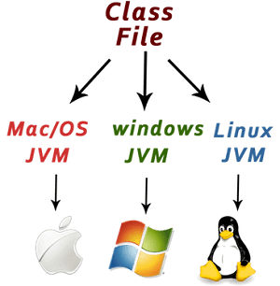

Java is platform independent because it is different from other languages like [C](https://www.javatpoint.com/c-programming-language-tutorial), [C++](https://www.javatpoint.com/cpp-tutorial), etc. which are compiled into platform specific machines while Java is a write once, run anywhere language. A platform is the hardware or software environment in which a program runs.

There are two types of platforms software-based and hardware-based. Java provides a software-based platform.

The Java platform differs from most other platforms in the sense that it is a software-based platform that runs on top of other hardware-based platforms. It has two components:

1. Runtime Environment
2. API(Application Programming Interface)

Java code can be executed on multiple platforms, for example, Windows, Linux, Sun Solaris, Mac/OS, etc. Java code is compiled by the compiler and converted into bytecode. This bytecode is a platform-independent code because it can be run on multiple platforms, i.e., Write Once and Run Anywhere (WORA).

### **Secured**

Java is best known for its security. With Java, we can develop virus-free systems. Java is secured because:

* **No explicit pointer**
* **Java Programs run inside a virtual machine sandbox**

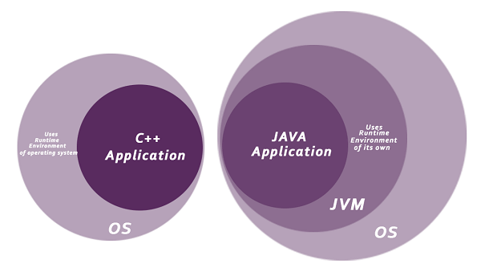

* **Classloader:** Classloader in Java is a part of the Java Runtime Environment (JRE) which is used to load Java classes into the Java Virtual Machine dynamically. It adds security by separating the package for the classes of the local file system from those that are imported from network sources.
* **Bytecode Verifier:** It checks the code fragments for illegal code that can violate access rights to objects.
* **Security Manager:** It determines what resources a class can access such as reading and writing to the local disk.

Java language provides these securities by default. Some security can also be provided by an application developer explicitly through SSL, JAAS, Cryptography, etc

### **Robust**

The English mining of Robust is strong. Java is robust because:

* It uses strong memory management.
* There is a lack of pointers that avoids security problems.
* Java provides automatic garbage collection which runs on the Java Virtual Machine to get rid of objects which are not being used by a Java application anymore.
* There are exception handling and the type checking mechanism in Java. All these points make Java robust.

### **Architecture-neutral**

Java is architecture neutral because there are no implementation dependent features, for example, the size of primitive types is fixed.

In C programming, int data type occupies 2 bytes of memory for 32-bit architecture and 4 bytes of memory for 64-bit architecture. However, it occupies 4 bytes of memory for both 32 and 64-bit architectures in Java.

### **Portable**

Java is portable because it facilitates you to carry the Java bytecode to any platform. It doesn't require any implementation.

### **High-performance**

Java is faster than other traditional interpreted programming languages because Java bytecode is "close" to native code. It is still a little bit slower than a compiled language (e.g., C++). Java is an interpreted language that is why it is slower than compiled languages, e.g., C, C++, etc.

### **Distributed**

Java is distributed because it facilitates users to create distributed applications in Java. RMI and EJB are used for creating distributed applications. This feature of Java makes us able to access files by calling the methods from any machine on the internet.

### **Multi-threaded**

A thread is like a separate program, executing concurrently. We can write Java programs that deal with many tasks at once by defining multiple threads. The main advantage of multi-threading is that it doesn't occupy memory for each thread. It shares a common memory area. Threads are important for multi-media, Web applications, etc.

### **Dynamic**

Java is a dynamic language. It supports the dynamic loading of classes. It means classes are loaded on demand. It also supports functions from its native languages, i.e., C and C++.

# **How to set path in Java**

For setting the permanent path of JDK, you need to follow these steps:

* Go to MyComputer properties -> advanced tab -> environment variables -> new tab of user variable -> write path in variable name -> write path of bin folder in variable value -> ok -> ok -> ok

# **Difference between JDK, JRE, and JVM**

### **JVM**

JVM (Java Virtual Machine) is an abstract machine. It is called a virtual machine because it doesn't physically exist. It is a specification that provides a runtime environment in which Java bytecode can be executed. It can also run those programs which are written in other languages and compiled to Java bytecode.

JVMs are available for many hardware and software platforms. JVM, JRE, and JDK are platform dependent because the configuration of each [OS](https://www.javatpoint.com/os-tutorial) is different from each other. However, Java is platform independent. There are three notions of the JVM: *specification*, *implementation*, and *instance*.

The JVM performs the following main tasks:

* Loads code
* Verifies code
* Executes code
* Provides runtime environment

### **JRE**

JRE is an acronym for Java Runtime Environment. It is also written as Java RTE. The Java Runtime Environment is a set of software tools which are used for developing Java applications. It is used to provide the runtime environment. It is the implementation of JVM. It physically exists. It contains a set of libraries + other files that JVM uses at runtime.

The implementation of JVM is also actively released by other companies besides Sun Micro Systems.

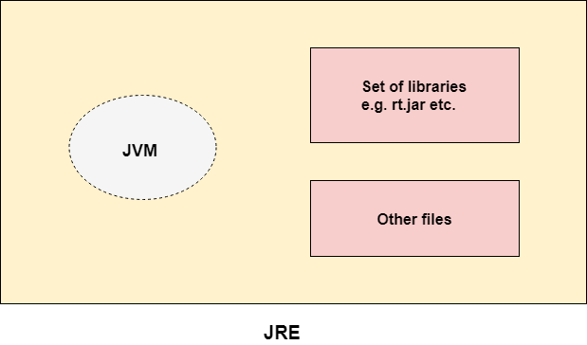

### **JDK**

JDK is an acronym for Java Development Kit. The Java Development Kit (JDK) is a software development environment which is used to develop Java applications and [applets](https://www.javatpoint.com/java-applet). It physically exists. It contains JRE + development tools.

JDK is an implementation of any one of the below given Java Platforms released by Oracle Corporation:

* Standard Edition Java Platform
* Enterprise Edition Java Platform
* Micro Edition Java Platform

The JDK contains a private Java Virtual Machine (JVM) and a few other resources such as an interpreter/loader (java), a compiler (javac), an archiver (jar), a documentation generator (Javadoc), etc. to complete the development of a Java Application.

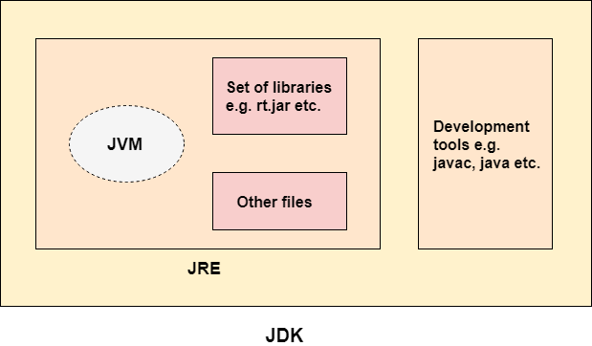

# **Java Command Line Arguments**

The java command-line argument is an argument i.e. passed at the time of running the java program.

The arguments passed from the console can be received in the java program and it can be used as an input.

### **Simple example of command-line argument in java**

|  |
| --- |
| In this example, we are receiving only one argument and printing it. To run this java program, you must pass at least one argument from the command prompt. |

1. **class** CommandLineExample{
2. **public** **static** **void** main(String args[]){
3. System.out.println("Your first argument is: "+args[0]);
4. }
5. }
6. compile by > javac CommandLineExample.java
7. run by > java CommandLineExample sonoo

Output: Your first argument is: sonoo

# **Data Types in Java**

Data types specify the different sizes and values that can be stored in the variable. There are two types of data types in Java:

1. **Primitive data types:** The primitive data types include boolean, char, byte, short, int, long, float and double.
2. **Non-primitive data types:** The non-primitive data types include [Classes](https://www.javatpoint.com/object-and-class-in-java), [Interfaces](https://www.javatpoint.com/interface-in-java), and [Arrays](https://www.javatpoint.com/array-in-java).

## Java Primitive Data Types

In Java language, primitive data types are the building blocks of data manipulation. These are the most basic data types available in [Java language](https://www.javatpoint.com/java-tutorial).

There are 8 types of primitive data types:

* boolean data type
* byte data type
* char data type
* short data type
* int data type
* long data type
* float data type
* double data type

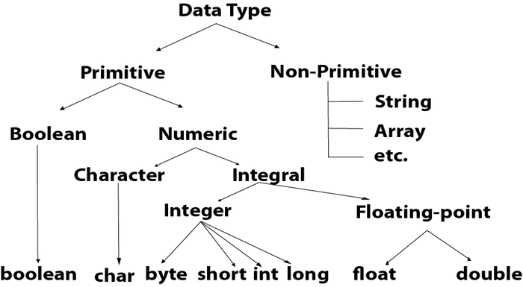

|  |  |  |
| --- | --- | --- |
| **Data Type** | **Default Value** | **Default size** |
| boolean | false | 1 bit |
| char | '\u0000' | 2 byte |
| byte | 0 | 1 byte |
| short | 0 | 2 byte |
| int | 0 | 4 byte |
| long | 0L | 8 byte |
| float | 0.0f | 4 byte |
| double | 0.0d | 8 byte |

## Boolean Data Type

The Boolean data type is used to store only two possible values: true and false. This data type is used for simple flags that track true/false conditions.

The Boolean data type specifies one bit of information, but its "size" can't be defined precisely.

**Example:**

1. Boolean one = **false**

## Byte Data Type

The byte data type is an example of primitive data type. It isan 8-bit signed two's complement integer. Its value-range lies between -128 to 127 (inclusive). Its minimum value is -128 and maximum value is 127. Its default value is 0.

The byte data type is used to save memory in large arrays where the memory savings is most required. It saves space because a byte is 4 times smaller than an integer. It can also be used in place of "int" data type.

**Example:**

1. **byte** a = 10, **byte** b = -20

## Short Data Type

The short data type is a 16-bit signed two's complement integer. Its value-range lies between -32,768 to 32,767 (inclusive). Its minimum value is -32,768 and maximum value is 32,767. Its default value is 0.

The short data type can also be used to save memory just like byte data type. A short data type is 2 times smaller than an integer.

**Example:**

1. **short** s = 10000, **short** r = -5000

## Int Data Type

The int data type is a 32-bit signed two's complement integer. Its value-range lies between - 2,147,483,648 (-2^31) to 2,147,483,647 (2^31 -1) (inclusive). Its minimum value is - 2,147,483,648and maximum value is 2,147,483,647. Its default value is 0.

The int data type is generally used as a default data type for integral values unless if there is no problem about memory.

**Example:**

1. **int** a = 100000, **int** b = -200000

## Long Data Type

The long data type is a 64-bit two's complement integer. Its value-range lies between -9,223,372,036,854,775,808(-2^63) to 9,223,372,036,854,775,807(2^63 -1)(inclusive). Its minimum value is - 9,223,372,036,854,775,808and maximum value is 9,223,372,036,854,775,807. Its default value is 0. The long data type is used when you need a range of values more than those provided by int.

**Example:**

1. **long** a = 100000L, **long** b = -200000L

## Float Data Type

The float data type is a single-precision 32-bit IEEE 754 floating point.Its value range is unlimited. It is recommended to use a float (instead of double) if you need to save memory in large arrays of floating point numbers. The float data type should never be used for precise values, such as currency. Its default value is 0.0F.

**Example:**

1. **float** f1 = 234.5f

## Double Data Type

The double data type is a double-precision 64-bit IEEE 754 floating point. Its value range is unlimited. The double data type is generally used for decimal values just like float. The double data type also should never be used for precise values, such as currency. Its default value is 0.0d.

**Example:**

1. **double** d1 = 12.3

## Char Data Type

The char data type is a single 16-bit Unicode character. Its value-range lies between '\u0000' (or 0) to '\uffff' (or 65,535 inclusive).The char data type is used to store characters.

**Example:**

1. **char** letterA = 'A'

## Java Non-Primitive Data Types

There are 8 types of non-primitive data types:

* Boolean data type
* Byte data type
* Character data type
* short data type
* Integer data type
* Long data type
* Float data type
* Double data type

## Wrapper Class

Primitive data types are wrapped into objects and objects to primitive.

Primitive to object -Autoboxing

Object to primitive - Unboxing

## Compile Time and Run Time Error

In Eclipse, compile time errors will be underlined in red. A compile time error is an error that is detected by the compiler. Common causes for compile time errors include:

* Syntax errors such as missing semi-colon or use of a reserved keyword (such as 'class').
* When you try and access a variable that is not in scope.
* When you declare multiple objects with the same name.

If the compiler detects any errors during compilation it will fail to build a new assembly (or class file in Java).

Even if your code has no compile time errors, errors can still occur on run-time. Errors such as 'logic errors' and 'runtime errors'. A good example of a runtime error is as followed:

* Pretend you're going to store an item in an array at index 5 but the array's size is only 4. The compiler won't detect an error here because it understands that the array size is subject to change but on run-time you'll be thrown an exception.

To detect which line exactly a run-time error occurs on you can use a combination of break points in Eclipse and proper exception handling.

## Naming Conventions

Using the right letter [case](https://www.thoughtco.com/java-is-case-sensitive-2034197) is the key to following a naming convention:

* **Lowercase** is where all the letters in a word are written without any capitalization (e.g., while, if, mypackage).
* **Uppercase** is where all the letters in a word are written in capitals. When there are more than two words in the name use underscores to separate them (e.g., MAX_HOURS, FIRST_DAY_OF_WEEK).
* **CamelCase** (also known as Upper CamelCase) is where each new word begins with a capital letter (e.g., CamelCase, CustomerAccount, PlayingCard).
* **Mixed case** (also known as Lower CamelCase) is the same as CamelCase except the first letter of the name is in lowercase (e.g., hasChildren, customerFirstName, customerLastName).

## Standard Java Naming Conventions

The below list outlines the standard Java naming conventions for each identifier type:

* **Packages:**Names should be in lowercase. With small projects that only have a few packages it's okay to just give them simple (but meaningful!) names:

package pokeranalyzer package mycalculator

In software companies and large projects where the packages might be imported into other classes, the names will normally be subdivided. Typically this will start with the company domain before being split into layers or features:

package com.mycompany.utilities package org.bobscompany.application.userinterface

* **Classes:** Names should be in CamelCase. Try to use nouns because a class is normally representing something in the real world:

class Customer class Account

* **Interfaces:** Names should be in CamelCase. They tend to have a name that describes an operation that a class can do:

interface Comparable interface Enumerable

Note that some programmers like to distinguish interfaces by beginning the name with an "I":

interface IComparable interface IEnumerable

* **Methods:**Names should be in mixed case. Use verbs to describe what the method does:

void calculateTax() string getSurname()

* **Variables:**Names should be in mixed case. The names should represent what the value of the variable represents:

string firstName int orderNumber

Only use very short names when the variables are short-lived, such as in for loops:

for (int i=0; i<20;i++) {   //i only lives in here }

* **Constants:**Names should be in uppercase.

static final int DEFAULT_WIDTH static final int MAX_HEIGHT

# **Java Control Statements | Control Flow in Java**

Java compiler executes the code from top to bottom. The statements in the code are executed according to the order in which they appear. However, [Java](https://www.javatpoint.com/java-tutorial) provides statements that can be used to control the flow of Java code. Such statements are called control flow statements. It is one of the fundamental features of Java, which provides a smooth flow of program.

Java provides three types of control flow statements.

1. Decision Making statements
   * if statements
   * switch statement
2. Loop statements
   * do while loop
   * while loop
   * for loop
   * for-each loop
3. Jump statements
   * break statement
   * continue statement

### **Decision-Making statements:**

As the name suggests, decision-making statements decide which statement to execute and when. Decision-making statements evaluate the Boolean expression and control the program flow depending upon the result of the condition provided. There are two types of decision-making statements in Java, i.e., If statement and switch statement.

### **1) If Statement:**

In Java, the "if" statement is used to evaluate a condition. The control of the program is diverted depending upon the specific condition. The condition of the If statement gives a Boolean value, either true or false. In Java, there are four types of if-statements given below.

1. Simple if statement
2. if-else statement
3. if-else-if ladder
4. Nested if-statement

### **1) Simple if statement:**

It is the most basic statement among all control flow statements in Java. It evaluates a Boolean expression and enables the program to enter a block of code if the expression evaluates to true.

Syntax of if statement is given below.

1. **if**(condition) {
2. statement 1; //executes when condition is true
3. }

Consider the following example in which we have used the **if** statement in the java code.

Student.java

**Student.java**

public class Student {

public static void main(String[] args) {

int x = 10;

int y = 12;

if(x+y> 20) {

System.out.println("x + y is greater than 20");

}

}

}

**Output:**

x + y is greater than 20

### **2) if-else statement**

The [if-else statement](https://www.javatpoint.com/java-if-else) is an extension to the if-statement, which uses another block of code, i.e., else block. The else block is executed if the condition of the if-block is evaluated as false.

**Syntax:**

1. **if**(condition) {
2. statement 1; //executes when condition is true
3. }
4. **else**{
5. statement 2; //executes when condition is false
6. }

Consider the following example.

**Student.java**

**public** **class** Student {

**public** **static** **void** main(String[] args) {

**int** x = 10;

**int** y = 12;

**if**(x+y < 10) {

System.out.println("x + y is less than      10");

}   **else** {

System.out.println("x + y is greater than 20");

}

}

}

**Output:**

x + y is greater than 20

**Syntax:**

**if**(condition) {

statement 1; //executes when condition is true

}

**else**{

statement 2; //executes when condition is false

}

Consider the following example.

**Student.java**

**public** **class** Student {

**public** **static** **void** main(String[] args) {

**int** x = 10;

**int** y = 12;

**if**(x+y < 10) {

System.out.println("x + y is less than      10");

}   **else** {

System.out.println("x + y is greater than 20");

}

}

}

**Output:**

x + y is greater than 20

### **Loop Statements**

In programming, sometimes we need to execute the block of code repeatedly while some condition evaluates to true. However, loop statements are used to execute the set of instructions in a repeated order. The execution of the set of instructions depends upon a particular condition.

In Java, we have three types of loops that execute similarly. However, there are differences in their syntax and condition checking time.

1. for loop
2. while loop
3. do-while loop

Let's understand the loop statements one by one.

### **Java for loop**

In Java, [for loop](https://www.javatpoint.com/java-for-loop) is similar to [C](https://www.javatpoint.com/c-programming-language-tutorial) and [C++](https://www.javatpoint.com/cpp-tutorial). It enables us to initialize the loop variable, check the condition, and increment/decrement in a single line of code. We use the for loop only when we exactly know the number of times, we want to execute the block of code.

1. **for**(initialization, condition, increment/decrement) {
2. //block of statements
3. }

The flow chart for the for-loop is given below.

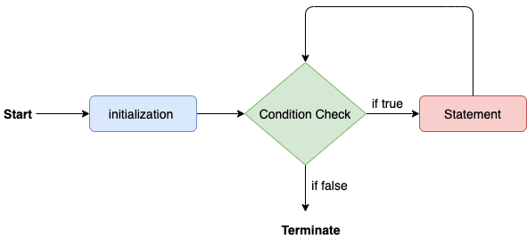

Consider the following example to understand the proper functioning of the for loop in java.

**Calculation.java**

**public** **class** Calculattion {

**public** **static** **void** main(String[] args) {

// TODO Auto-generated method stub

**int** sum = 0;

**for**(**int** j = 1; j<=10; j++) {

sum = sum + j;

}

System.out.println("The sum of first 10 natural numbers is " + sum);

}

}

**Output:**

The sum of first 10 natural numbers is 55

### **Java for-each loop**

Java provides an enhanced for loop to traverse the data structures like array or collection. In the for-each loop, we don't need to update the loop variable. The syntax to use the for-each loop in java is given below.

**for**(data_type var : array_name/collection_name){

//statements

}

Consider the following example to understand the functioning of the for-each loop in Java.

**Calculation.java**

**public** **class** Calculation {

**public** **static** **void** main(String[] args) {

// TODO Auto-generated method stub

String[] names = {"Java","C","C++","Python","JavaScript"};

System.out.println("Printing the content of the array names:\n");

**for**(String name:names) {

System.out.println(name);

}

}

}

**Output:**

Printing the content of the array names:

Java

C

C++

Python

JavaScript

### **Java while loop**

The [while loop](https://www.javatpoint.com/java-while-loop) is also used to iterate over the number of statements multiple times. However, if we don't know the number of iterations in advance, it is recommended to use a while loop. Unlike for loop, the initialization and increment/decrement doesn't take place inside the loop statement in while loop.

It is also known as the entry-controlled loop since the condition is checked at the start of the loop. If the condition is true, then the loop body will be executed; otherwise, the statements after the loop will be executed.

The syntax of the while loop is given below.

**while**(condition){

//looping statements

}

The flow chart for the while loop is given in the following image.

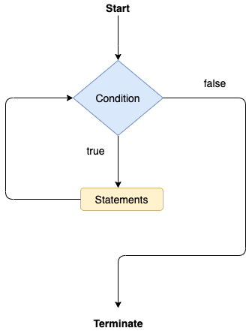

Consider the following example.

**Calculation .java**

**public** **class** Calculation {

**public** **static** **void** main(String[] args) {

// TODO Auto-generated method stub

**int** i = 0;

System.out.println("Printing the list of first 10 even numbers \n");

**while**(i<=10) {

System.out.println(i);

i = i + 2;

}

}

}

**Output:**

Printing the list of first 10 even numbers

0

2

4

6

8

10

### **Java do-while loop**

The [do-while loop](https://www.javatpoint.com/java-do-while-loop) checks the condition at the end of the loop after executing the loop statements. When the number of iteration is not known and we have to execute the loop at least once, we can use do-while loop.

It is also known as the exit-controlled loop since the condition is not checked in advance. The syntax of the do-while loop is given below.

**do**

{

//statements

} **while** (condition);

The flow chart of the do-while loop is given in the following image.

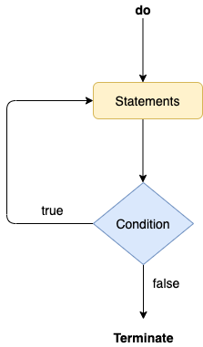

Consider the following example to understand the functioning of the do-while loop in Java.

**Calculation.java**

**public** **class** Calculation {

**public** **static** **void** main(String[] args) {

// TODO Auto-generated method stub

**int** i = 0;

System.out.println("Printing the list of first 10 even numbers \n");

**do** {

System.out.println(i);

i = i + 2;

}**while**(i<=10);

}

}

**Output:**

Printing the list of first 10 even numbers

0

2

4

6

8

10

### **Jump Statements**

Jump statements are used to transfer the control of the program to the specific statements. In other words, jump statements transfer the execution control to the other part of the program. There are two types of jump statements in Java, i.e., break and continue.

### **Java break statement**

As the name suggests, the [break statement](https://www.javatpoint.com/java-break) is used to break the current flow of the program and transfer the control to the next statement outside a loop or switch statement. However, it breaks only the inner loop in the case of the nested loop.

The break statement cannot be used independently in the Java program, i.e., it can only be written inside the loop or switch statement.

**The break statement example with for loop**

Consider the following example in which we have used the break statement with the for loop.

**BreakExample.java**

**public** **class** BreakExample {

**public** **static** **void** main(String[] args) {

// TODO Auto-generated method stub

**for**(**int** i = 0; i<= 10; i++) {

System.out.println(i);

**if**(i==6) {

**break**;

}

}

}

}

**Output:**

0

1

2

3

4

5

6

### **Java continue statement**

Unlike break statement, the [continue statement](https://www.javatpoint.com/java-continue) doesn't break the loop, whereas, it skips the specific part of the loop and jumps to the next iteration of the loop immediately.

Consider the following example to understand the functioning of the continue statement in Java.

**public** **class** ContinueExample {

**public** **static** **void** main(String[] args) {

// TODO Auto-generated method stub

**for**(**int** i = 0; i<= 2; i++) {

**for** (**int** j = i; j<=5; j++) {

**if**(j == 4) {

**continue**;

}

System.out.println(j);

}

}

}

}

**Output:**

0

1

2

3

5

1

2

3

5

2

3

5

# **Java Comments**

The [Java](https://www.javatpoint.com/java-tutorial) comments are the statements in a program that are not executed by the compiler and interpreter.

## Why do we use comments in a code?

* Comments are used to make the program more readable by adding the details of the code.
* It makes easy to maintain the code and to find the errors easily.
* The comments can be used to provide information or explanation about the [variable](https://www.javatpoint.com/java-variables), method, [class](https://www.javatpoint.com/object-and-class-in-java), or any statement.
* It can also be used to prevent the execution of program code while testing the alternative code.

## Types of Java Comments

There are three types of comments in Java.

1. Single Line Comment
2. Multi Line Comment
3. Documentation Comment

### **1) Java Single Line Comment**

The single-line comment is used to comment only one line of the code. It is the widely used and easiest way of commenting the statements.

Single line comments starts with two forward slashes **(//)**. Any text in front of // is not executed by Java.

**Syntax:**

//This is single line comment

Let's use single line comment in a Java program.

**CommentExample1.java**

**public** **class** CommentExample1 {

**public** **static** **void** main(String[] args) {

**int** i=10; // i is a variable with value 10

System.out.println(i);  //printing the variable i

}

}

**Output:**

10

### **2) Java Multi Line Comment**

The multi-line comment is used to comment multiple lines of code. It can be used to explain a complex code snippet or to comment multiple lines of code at a time (as it will be difficult to use single-line comments there).

Multi-line comments are placed between /* and */. Any text between /* and */ is not executed by Java.

**Syntax:**

/*

This

is

multi line

comment

*/

**CommentExample2.java**

**public** **class** CommentExample2 {

**public** **static** **void** main(String[] args) {

/* Let's declare and

 print variable in java. */

**int** i=10;

    System.out.println(i);

/* float j = 5.9;

    float k = 4.4;

    System.out.println( j + k ); */

}

}

**Output:**

10

# **Java Variables**

A variable is a container which holds the value while the [Java program](https://www.javatpoint.com/simple-program-of-java) is executed. A variable is assigned with a data type.

Variable is a name of memory location. There are three types of variables in java: local, instance and static.

There are two types of [data types in Java](https://www.javatpoint.com/java-data-types): primitive and non-primitive.

Backward Skip 10sPlay VideoForward Skip 10s

## Variable

A variable is the name of a reserved area allocated in memory. In other words, it is a name of the memory location. It is a combination of "vary + able" which means its value can be changed.

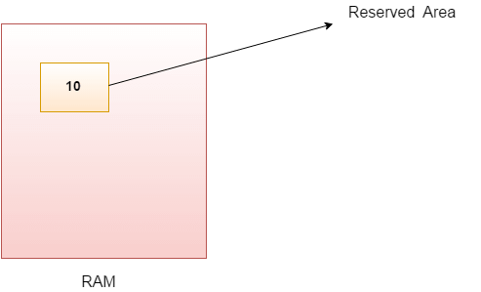

1. **int** data=50;//Here data is variable

### **Types of Variables**

There are three types of variables in [Java](https://www.javatpoint.com/java-tutorial):

* local variable
* instance variable
* static variable

#### **1) Local Variable**

A variable declared inside the body of the method is called local variable. You can use this variable only within that method and the other methods in the class aren't even aware that the variable exists.

A local variable cannot be defined with "static" keyword.

#### **2) Instance Variable**

A variable declared inside the class but outside the body of the method, is called an instance variable. It is not declared as [static](https://www.javatpoint.com/static-keyword-in-java).

It is called an instance variable because its value is instance-specific and is not shared among instances.

#### **3) Static variable**

A variable that is declared as static is called a static variable. It cannot be local. You can create a single copy of the static variable and share it among all the instances of the class. Memory allocation for static variables happens only once when the class is loaded in the memory.

### **Example to understand the types of variables in java**

## class Variables{

## static boolean a = true; //declaring static variable

## int c= 5; //instance variable

## public static void main (String args[]){

## //boolean a = true; //declaring local variable

## System.out.println(a);

## Variables.display(); //calling a method called display

## Variables obj = new Variables(); //object creation

## System.out.println(obj.c);

## }

## public static void display(){

## System.out.println(a);

## }

## }

# **Java Arrays**

Normally, an array is a collection of similar type of elements which has contiguous memory location.

**Java array** is an object which contains elements of a similar data type. Additionally, The elements of an array are stored in a contiguous memory location. It is a data structure where we store similar elements. We can store only a fixed set of elements in a Java array.

Array in Java is index-based, the first element of the array is stored at the 0th index, 2nd element is stored on 1st index and so on.

In Java, array is an object of a dynamically generated class. Java array inherits the Object class, and implements the Serializable as well as Cloneable interfaces. We can store primitive values or objects in an array in Java. Like C/C++, we can also create single dimentional or multidimentional arrays in Java.

Moreover, Java provides the feature of anonymous arrays which is not available in C/C++.

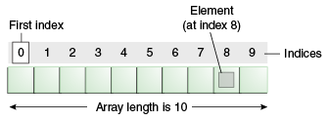

### **Advantages**

* **Code Optimization:** It makes the code optimized, we can retrieve or sort the data efficiently.
* **Random access:** We can get any data located at an index position.

### **Disadvantages**

* **Size Limit:** We can store only the fixed size of elements in the array. It doesn't grow its size at runtime. To solve this problem, collection framework is used in Java which grows automatically.

### **Types of Array in java**

There are two types of array.

* Single Dimensional Array
* Multidimensional Array

## Single Dimensional Array in Java

**Syntax to Declare an Array in Java**

1. dataType[] arr; (or)
2. dataType []arr; (or)
3. dataType arr[];

**Instantiation of an Array in Java**

arrayRefVar=**new** datatype[size];

### **Example of Java Array**

Let's see the simple example of java array, where we are going to declare, instantiate, initialize and traverse an array.

//Java Program to illustrate how to declare, instantiate, initialize

//and traverse the Java array.

**class** Testarray{

**public** **static** **void** main(String args[]){

**int** a[]=**new** **int**[5];//declaration and instantiation

a[0]=10;//initialization

a[1]=20;

a[2]=70;

a[3]=40;

a[4]=50;

//traversing array

**for**(**int** i=0;i<a.length;i++)//length is the property of array

System.out.println(a[i]);

}}

Output:

10

20

70

40

50

Declaration, Instantiation and Initialization of Java Array

We can declare, instantiate and initialize the java array together by:

**int** a[]={33,3,4,5};//declaration, instantiation and initialization

## For-each Loop for Java Array

We can also print the Java array using [**for-each loop**](https://www.javatpoint.com/for-each-loop). The Java for-each loop prints the array elements one by one. It holds an array element in a variable, then executes the body of the loop.

The syntax of the for-each loop is given below:

**for**(data_type variable:array){

//body of the loop

}

# **Method in Java**

In general, a **method** is a way to perform some task. Similarly, the **method in Java** is a collection of instructions that performs a specific task. It provides the reusability of code. We can also easily modify code using **methods**. In this section, we will learn **what is a method in Java, types of methods, method declaration,** and **how to call a method in Java**.

## What is a method in Java?

A **method** is a block of code or collection of statements or a set of code grouped together to perform a certain task or operation. It is used to achieve the **reusability** of code. We write a method once and use it many times. We do not require to write code again and again. It also provides the **easy modification** and **readability** of code, just by adding or removing a chunk of code. The method is executed only when we call or invoke it.

The most important method in Java is the **main()** method. If you want to read more about the main() method, go through the link <https://www.javatpoint.com/java-main-method>.

### **Method Declaration**

The method declaration provides information about method attributes, such as visibility, return-type, name, and arguments. It has six components that are known as **method header**, as we have shown in the following figure.

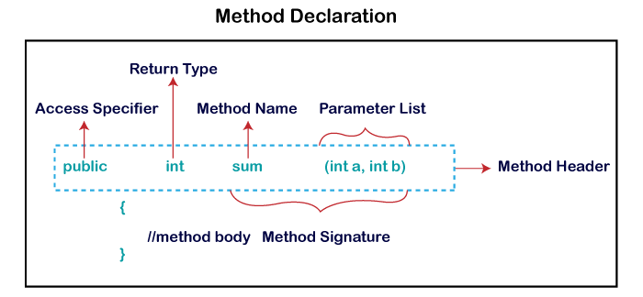

**Method Signature:** Every method has a method signature. It is a part of the method declaration. It includes the **method name** and **parameter list**.

**Access Specifier:** Access specifier or modifier is the access type of the method. It specifies the visibility of the method. Java provides **four** types of access specifier:

* **Public:** The method is accessible by all classes when we use public specifier in our application.
* **Private:** When we use a private access specifier, the method is accessible only in the classes in which it is defined.
* **Protected:** When we use protected access specifier, the method is accessible within the same package or subclasses in a different package.
* **Default:** When we do not use any access specifier in the method declaration, Java uses default access specifier by default. It is visible only from the same package only.

**Return Type:** Return type is a data type that the method returns. It may have a primitive data type, object, collection, void, etc. If the method does not return anything, we use void keyword.

**Method Name:** It is a unique name that is used to define the name of a method. It must be corresponding to the functionality of the method. Suppose, if we are creating a method for subtraction of two numbers, the method name must be **subtraction().** A method is invoked by its name.

**Parameter List:** It is the list of parameters separated by a comma and enclosed in the pair of parentheses. It contains the data type and variable name. If the method has no parameter, left the parentheses blank.

**Method Body:** It is a part of the method declaration. It contains all the actions to be performed. It is enclosed within the pair of curly braces.

Naming a Method

While defining a method, remember that the method name must be a **verb** and start with a **lowercase** letter. If the method name has more than two words, the first name must be a verb followed by adjective or noun. In the multi-word method name, the first letter of each word must be in **uppercase** except the first word. For example:

**Single-word method name:** sum(), area()

## Types of Method

There are two types of methods in Java:

* Predefined Method
* User-defined Method

### **Predefined Method**

In Java, predefined methods are the method that is already defined in the Java class libraries is known as predefined methods. It is also known as the **standard library method** or **built-in method**. We can directly use these methods just by calling them in the program at any point. Some pre-defined methods are **length(), equals(), compareTo(), sqrt(),** etc. When we call any of the predefined methods in our program, a series of codes related to the corresponding method runs in the background that is already stored in the library.

Each and every predefined method is defined inside a class. Such as **print()** method is defined in the **java.io.PrintStream** class. It prints the statement that we write inside the method. For example, **print("Java")**, it prints Java on the console.

Let's see an example of the predefined method.

**Demo.java**

**public** **class** Demo

{

**public** **static** **void** main(String[] args)

{

// using the max() method of Math class

System.out.print("The maximum number is: " + Math.max(9,7));

}

}

**Output:**

The maximum number is: 9

### **User-defined Method**

The method written by the user or programmer is known as **a user-defined** method. These methods are modified according to the requirement.

### **How to Create a User-defined Method**

Let's create a user defined method that checks the number is even or odd. First, we will define the method.

//user defined method

**public** **static** **void** findEvenOdd(**int** num)

{

//method body

**if**(num%2==0)

System.out.println(num+" is even");

**else**

System.out.println(num+" is odd");

}

We have defined the above method named findevenodd(). It has a parameter **num** of type int. The method does not return any value that's why we have used void. The method body contains the steps to check the number is even or odd. If the number is even, it prints the number **is even**, else prints the number **is odd**.

### **How to Call or Invoke a User-defined Method**

Once we have defined a method, it should be called. The calling of a method in a program is simple. When we call or invoke a user-defined method, the program control transfer to the called method.

**import** java.util.Scanner;

**public** **class** EvenOdd

{

**public** **static** **void** main (String args[])

{

//creating Scanner class object

Scanner scan=**new** Scanner(System.in);

System.out.print("Enter the number: ");

//reading value from the user

**int** num=scan.nextInt();

//method calling

findEvenOdd(num);

}

In the above code snippet, as soon as the compiler reaches at line **findEvenOdd(num),** the control transfer to the method and gives the output accordingly.

### **Static Method**

A method that has static keyword is known as static method. In other words, a method that belongs to a class rather than an instance of a class is known as a static method. We can also create a static method by using the keyword **static** before the method name.

The main advantage of a static method is that we can call it without creating an object. It can access static data members and also change the value of it. It is used to create an instance method. It is invoked by using the class name. The best example of a static method is the **main()** method.

### **Example of static method**

**Display.java**

**public** **class** Display

{

**public** **static** **void** main(String[] args)

{

show();

}

**static** **void** show()

{

System.out.println("It is an example of static method.");

}

}

**Output:**

It is an example of a static method.

### **Instance Method**

The method of the class is known as an **instance method**. It is a **non-static** method defined in the class. Before calling or invoking the instance method, it is necessary to create an object of its class. Let's see an example of an instance method.

**InstanceMethodExample.java**

**public** **class** InstanceMethodExample

{

**public** **static** **void** main(String [] args)

{

//Creating an object of the class

InstanceMethodExample obj = **new** InstanceMethodExample();

//invoking instance method

System.out.println("The sum is: "+obj.add(12, 13));

}

**int** s;

//user-defined method because we have not used static keyword

**public** **int** add(**int** a, **int** b)

{

s = a+b;

//returning the sum

**return** s;

}

}

**Output:**

The sum is: 25

Java String

In [Java](https://www.javatpoint.com/java-tutorial), string is basically an object that represents sequence of char values. An [array](https://www.javatpoint.com/array-in-java) of characters works same as Java string. For example:

1. **char**[] ch={'j','a','v','a','t','p','o','i','n','t'};
2. String s=**new** String(ch);

is same as:

1. String s="javatpoint";

**Java String** class provides a lot of methods to perform operations on strings such as compare(), concat(), equals(), split(), length(), replace(), compareTo(), intern(), substring() etc.

The java.lang.String class implements *Serializable*, *Comparable* and *CharSequence* [interfaces](https://www.javatpoint.com/interface-in-java).

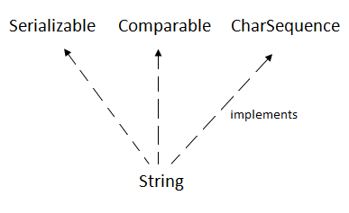

## CharSequence Interface

The CharSequence interface is used to represent the sequence of characters. String, [StringBuffer](https://www.javatpoint.com/StringBuffer-class) and [StringBuilder](https://www.javatpoint.com/StringBuilder-class) classes implement it. It means, we can create strings in Java by using these three classes.

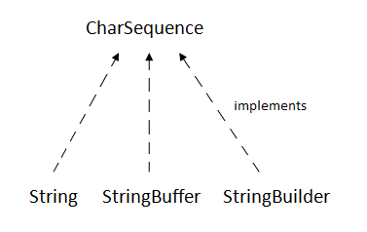

The Java String is immutable which means it cannot be changed. Whenever we change any string, a new instance is created. For mutable strings, you can use StringBuffer and StringBuilder classes.

We will discuss immutable string later. Let's first understand what String in Java is and how to create the String object.

### **What is String in Java?**

Generally, String is a sequence of characters. But in Java, string is an object that represents a sequence of characters. The java.lang.String class is used to create a string object.

### **How to create a string object?**

There are two ways to create String object:

1. By string literal
2. By new keyword

### **1) String Literal**

Java String literal is created by using double quotes. For Example:

1. String s="welcome";

Each time you create a string literal, the JVM checks the "string constant pool" first. If the string already exists in the pool, a reference to the pooled instance is returned. If the string doesn't exist in the pool, a new string instance is created and placed in the pool. For example:

1. String s1="Welcome";
2. String s2="Welcome";//It doesn't create a new instance

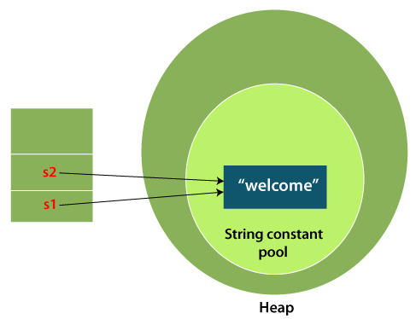

In the above example, only one object will be created. Firstly, JVM will not find any string object with the value "Welcome" in string constant pool that is why it will create a new object. After that it will find the string with the value "Welcome" in the pool, it will not create a new object but will return the reference to the same instance.

### **2) By new keyword**

1. String s=new String("Welcome");//creates two objects and one reference variable

In such case, [JVM](https://www.javatpoint.com/jvm-java-virtual-machine) will create a new string object in normal (non-pool) heap memory, and the literal "Welcome" will be placed in the string constant pool. The variable s will refer to the object in a heap (non-pool).

### **Java String Example**

**StringExample.java**

1. public class StringExample{
2. public static void main(String args[]){
3. String s1="java";//creating string by Java string literal
4. char ch[]={'s','t','r','i','n','g','s'};
5. String s2=new String(ch);//converting char array to string
6. String s3=new String("example");//creating Java string by new keyword
7. System.out.println(s1);
8. System.out.println(s2);
9. System.out.println(s3);
10. }}

[Test it Now](https://www.javatpoint.com/opr/test.jsp?filename=StringExample)

**Output:**

java

strings

example

### **Java String class methods**

The java.lang.String class provides many useful methods to perform operations on sequence of char values.

|  |  |  |
| --- | --- | --- |
| **No.** | **Method** | **Description** |
| 1 | [char charAt(int index)](https://www.javatpoint.com/java-string-charat) | It returns char value for the particular index |
| 2 | [int length()](https://www.javatpoint.com/java-string-length) | It returns string length |
| 3 | [static String format(String format, Object... args)](https://www.javatpoint.com/java-string-format) | It returns a formatted string. |
| 4 | [static String format(Locale l, String format, Object... args)](https://www.javatpoint.com/java-string-format) | It returns formatted string with given locale. |
| 5 | [String substring(int beginIndex)](https://www.javatpoint.com/java-string-substring) | It returns substring for given begin index. |
| 6 | [String substring(int beginIndex, int endIndex)](https://www.javatpoint.com/java-string-substring) | It returns substring for given begin index and end index. |
| 7 | [boolean contains(CharSequence s)](https://www.javatpoint.com/java-string-contains) | It returns true or false after matching the sequence of char value. |
| 8 | [static String join(CharSequence delimiter, CharSequence... elements)](https://www.javatpoint.com/java-string-join) | It returns a joined string. |
| 9 | [static String join(CharSequence delimiter, Iterable<? extends CharSequence> elements)](https://www.javatpoint.com/java-string-join) | It returns a joined string. |
| 10 | [boolean equals(Object another)](https://www.javatpoint.com/java-string-equals) | It checks the equality of string with the given object. |
| 11 | [boolean isEmpty()](https://www.javatpoint.com/java-string-isempty) | It checks if string is empty. |
| 12 | [String concat(String str)](https://www.javatpoint.com/java-string-concat) | It concatenates the specified string. |
| 13 | [String replace(char old, char new)](https://www.javatpoint.com/java-string-replace) | It replaces all occurrences of the specified char value. |
| 14 | [String replace(CharSequence old, CharSequence new)](https://www.javatpoint.com/java-string-replace) | It replaces all occurrences of the specified CharSequence. |
| 15 | [static String equalsIgnoreCase(String another)](https://www.javatpoint.com/java-string-equalsignorecase) | It compares another string. It doesn't check case. |
| 16 | [String[] split(String regex)](https://www.javatpoint.com/java-string-split) | It returns a split string matching regex. |
| 17 | [String[] split(String regex, int limit)](https://www.javatpoint.com/java-string-split) | It returns a split string matching regex and limit. |
| 18 | [String intern()](https://www.javatpoint.com/java-string-intern) | It returns an interned string. |
| 19 | [int indexOf(int ch)](https://www.javatpoint.com/java-string-indexof) | It returns the specified char value index. |
| 20 | [int indexOf(int ch, int fromIndex)](https://www.javatpoint.com/java-string-indexof) | It returns the specified char value index starting with given index. |
| 21 | [int indexOf(String substring)](https://www.javatpoint.com/java-string-indexof) | It returns the specified substring index. |
| 22 | [int indexOf(String substring, int fromIndex)](https://www.javatpoint.com/java-string-indexof) | It returns the specified substring index starting with given index. |
| 23 | [String toLowerCase()](https://www.javatpoint.com/java-string-tolowercase) | It returns a string in lowercase. |
| 24 | [String toLowerCase(Locale l)](https://www.javatpoint.com/java-string-tolowercase) | It returns a string in lowercase using specified locale. |
| 25 | [String toUpperCase()](https://www.javatpoint.com/java-string-touppercase) | It returns a string in uppercase. |
| 26 | [String toUpperCase(Locale l)](https://www.javatpoint.com/java-string-touppercase) | It returns a string in uppercase using specified locale. |
| 27 | [String trim()](https://www.javatpoint.com/java-string-trim) | It removes beginning and ending spaces of this string. |
| 28 | [static String valueOf(int value)](https://www.javatpoint.com/java-string-valueof) | It converts given type into string. It is an overloaded method. |

# **Java StringBuffer Class**

Java StringBuffer class is used to create mutable (modifiable) String objects. The StringBuffer class in Java is the same as String class except it is mutable i.e. it can be changed.

#### **Note: Java StringBuffer class is thread-safe i.e. multiple threads cannot access it simultaneously. So it is safe and will result in an order.**

### **Important Constructors of StringBuffer Class**

|  |  |
| --- | --- |
| **Constructor** | **Description** |
| StringBuffer() | It creates an empty String buffer with the initial capacity of 16. |
| StringBuffer(String str) | It creates a String buffer with the specified string.. |
| StringBuffer(int capacity) | It creates an empty String buffer with the specified capacity as length. |

### **Important methods of StringBuffer class**

|  |  |  |
| --- | --- | --- |
| **Modifier and Type** | **Method** | **Description** |
| public synchronized StringBuffer | append(String s) | It is used to append the specified string with this string. The append() method is overloaded like append(char), append(boolean), append(int), append(float), append(double) etc. |
| public synchronized StringBuffer | insert(int offset, String s) | It is used to insert the specified string with this string at the specified position. The insert() method is overloaded like insert(int, char), insert(int, boolean), insert(int, int), insert(int, float), insert(int, double) etc. |
| public synchronized StringBuffer | replace(int startIndex, int endIndex, String str) | It is used to replace the string from specified startIndex and endIndex. |
| public synchronized StringBuffer | delete(int startIndex, int endIndex) | It is used to delete the string from specified startIndex and endIndex. |
| public synchronized StringBuffer | reverse() | is used to reverse the string. |
| public int | capacity() | It is used to return the current capacity. |
| public void | ensureCapacity(int minimumCapacity) | It is used to ensure the capacity at least equal to the given minimum. |
| public char | charAt(int index) | It is used to return the character at the specified position. |
| public int | length() | It is used to return the length of the string i.e. total number of characters. |
| public String | substring(int beginIndex) | It is used to return the substring from the specified beginIndex. |
| public String | substring(int beginIndex, int endIndex) | It is used to return the substring from the specified beginIndex and endIndex. |

### **What is a mutable String?**

A String that can be modified or changed is known as mutable String. StringBuffer and StringBuilder classes are used for creating mutable strings.

### **1) StringBuffer Class append() Method**

The append() method concatenates the given argument with this String.

1. **class** StringBufferExample{
2. **public** **static** **void** main(String args[]){
3. StringBuffer sb=**new** StringBuffer("Hello ");
4. sb.append("Java");//now original string is changed
5. System.out.println(sb);//prints Hello Java
6. }
7. }

**Output:**

Hello Java

# **Java StringBuilder Class**

Java StringBuilder class is used to create mutable (modifiable) String. The Java StringBuilder class is same as StringBuffer class except that it is non-synchronized. It is available since JDK 1.5.

## Important Constructors of StringBuilder class

|  |  |
| --- | --- |
| **Constructor** | **Description** |
| StringBuilder() | It creates an empty String Builder with the initial capacity of 16. |
| StringBuilder(String str) | It creates a String Builder with the specified string. |
| StringBuilder(int length) | It creates an empty String Builder with the specified capacity as length. |

## Important methods of StringBuilder class

|  |  |
| --- | --- |
| **Method** | **Description** |
| public StringBuilder append(String s) | It is used to append the specified string with this string. The append() method is overloaded like append(char), append(boolean), append(int), append(float), append(double) etc. |
| public StringBuilder insert(int offset, String s) | It is used to insert the specified string with this string at the specified position. The insert() method is overloaded like insert(int, char), insert(int, boolean), insert(int, int), insert(int, float), insert(int, double) etc. |
| public StringBuilder replace(int startIndex, int endIndex, String str) | It is used to replace the string from specified startIndex and endIndex. |
| public StringBuilder delete(int startIndex, int endIndex) | It is used to delete the string from specified startIndex and endIndex. |
| public StringBuilder reverse() | It is used to reverse the string. |
| public int capacity() | It is used to return the current capacity. |
| public void ensureCapacity(int minimumCapacity) | It is used to ensure the capacity at least equal to the given minimum. |
| public char charAt(int index) | It is used to return the character at the specified position. |
| public int length() | It is used to return the length of the string i.e. total number of characters. |
| public String substring(int beginIndex) | It is used to return the substring from the specified beginIndex. |
| public String substring(int beginIndex, int endIndex) | It is used to return the substring from the specified beginIndex and endIndex. |

## Java StringBuilder Examples

Let's see the examples of different methods of StringBuilder class.

### **1) StringBuilder append() method**

The StringBuilder append() method concatenates the given argument with this String.

**StringBuilderExample.java**

1. **class** StringBuilderExample{
2. **public** **static** **void** main(String args[]){
3. StringBuilder sb=**new** StringBuilder("Hello ");
4. sb.append("Java");//now original string is changed
5. System.out.println(sb);//prints Hello Java
6. }
7. }

**Output:**

Hello Java

# **this keyword in Java**

There can be a lot of usage of **Java this keyword**. In Java, this is a **reference variable** that refers to the current object.

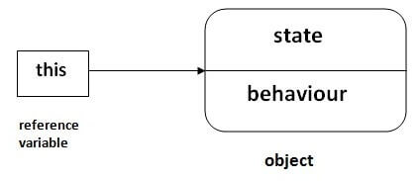

## Usage of Java this keyword

Here is given the 6 usage of java this keyword.

1. [this can be used to refer current class instance variable.](https://www.javatpoint.com/this1)
2. [this can be used to invoke current class method (implicitly)](https://www.javatpoint.com/this2)
3. [this() can be used to invoke current class constructor.](https://www.javatpoint.com/this3)
4. [this can be passed as an argument in the method call.](https://www.javatpoint.com/this4)
5. [this can be passed as argument in the constructor call.](https://www.javatpoint.com/this5)
6. [this can be used to return the current class instance from the method.](https://www.javatpoint.com/this6)

### **1) this: to refer current class instance variable**

The this keyword can be used to refer current class instance variable. If there is ambiguity between the instance variables and parameters, this keyword resolves the problem of ambiguity.

1. class Student{
2. int rollno;
3. String name;
4. float fee;
5. Student(int rollno,String name,float fee){
6. this.rollno=rollno;
7. this.name=name;
8. this.fee=fee;
9. }
10. void display(){System.out.println(rollno+" "+name+" "+fee);}
11. }
13. class TestThis2{
14. public static void main(String args[]){
15. Student s1=new Student(111,"ankit",5000f);
16. Student s2=new Student(112,"sumit",6000f);
17. s1.display();
18. s2.display();
19. }}

[Test it Now](https://www.javatpoint.com/opr/test.jsp?filename=TestThis2)

**Output:**

111 ankit 5000.0

112 sumit 6000.0

If local variables(formal arguments) and instance variables are different, there is no need to use this keyword like in the following program:

### **2) this: to invoke current class method**

You may invoke the method of the current class by using the this keyword. If you don't use the this keyword, compiler automatically adds this keyword while invoking the method. Let's see the example

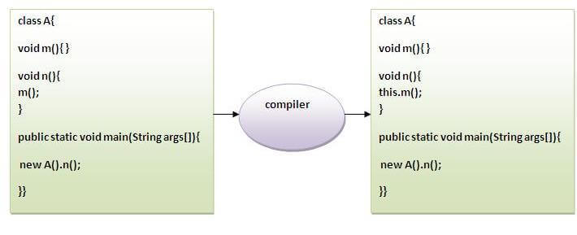

1. Baclass A{
2. void m(){System.out.println("hello m");}
3. void n(){
4. System.out.println("hello n");
5. //m();//same as this.m()
6. this.m();
7. }
8. }
9. class TestThis4{
10. public static void main(String args[]){
11. A a=new A();
12. a.n();
13. }}

[Test it Now](https://www.javatpoint.com/opr/test.jsp?filename=TestThis4)

**Output:**

hello n

hello m

### **3) this() : to invoke current class constructor**

The this() constructor call can be used to invoke the current class constructor. It is used to reuse the constructor. In other words, it is used for constructor chaining.

**Calling default constructor from parameterized constructor:**

1. class A{
2. A(){System.out.println("hello a");}
3. A(int x){
4. this();
5. System.out.println(x);
6. }
7. }
8. class TestThis5{
9. public static void main(String args[]){
10. A a=new A(10);
11. }}

[Test it Now](https://www.javatpoint.com/opr/test.jsp?filename=TestThis5)

**Output:**

hello a

10

Java Package

A **java package** is a group of similar types of classes, interfaces and sub-packages.

Package in java can be categorized in two form, built-in package and user-defined package.

There are many built-in packages such as java, lang, awt, javax, swing, net, io, util, sql etc.

## Advantage of Java Package

1) Java package is used to categorize the classes and interfaces so that they can be easily maintained.

2) Java package provides access protection.

3) Java package removes naming collision.

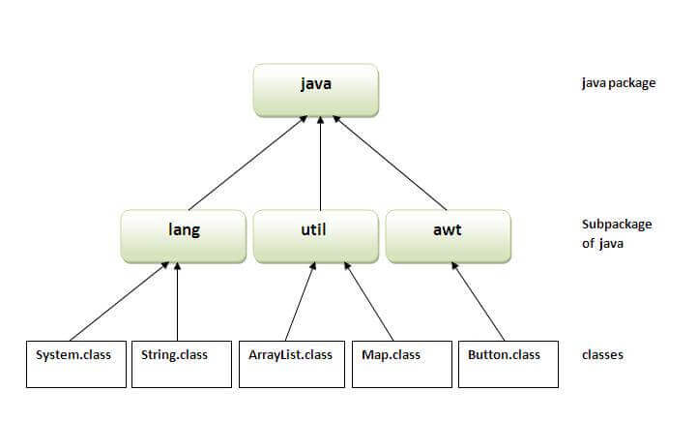

## Simple example of java package

The **package keyword** is used to create a package in java.

1. //save as Simple.java
2. package mypack;
3. public class Simple{
4. public static void main(String args[]){
5. System.out.println("Welcome to package");
6. }
7. }

Access Modifiers in Java

There are two types of modifiers in Java: **access modifiers** and **non-access modifiers**.

The access modifiers in Java specifies the accessibility or scope of a field, method, constructor, or class. We can change the access level of fields, constructors, methods, and class by applying the access modifier on it.

There are four types of Java access modifiers:

1. **Private**: The access level of a private modifier is only within the class. It cannot be accessed from outside the class.
2. **Default**: The access level of a default modifier is only within the package. It cannot be accessed from outside the package. If you do not specify any access level, it will be the default.
3. **Protected**: The access level of a protected modifier is within the package and outside the package through child class. If you do not make the child class, it cannot be accessed from outside the package.
4. **Public**: The access level of a public modifier is everywhere. It can be accessed from within the class, outside the class, within the package and outside the package.

There are many non-access modifiers, such as static, abstract, synchronized, native, volatile, transient, etc. Here, we are going to learn the access modifiers only.

### **Understanding Java Access Modifiers**

Let's understand the access modifiers in Java by a simple table.

|  |  |  |  |  |
| --- | --- | --- | --- | --- |
| **Access Modifier** | **within class** | **within package** | **outside package by subclass only** | **outside package** |
| **Private** | Y | N | N | N |
| **Default** | Y | Y | N | N |
| **Protected** | Y | Y | Y | N |
| **Public** | Y | Y | Y | Y |

### **1) Private**

The private access modifier is accessible only within the class.

**Simple example of private access modifier**

In this example, we have created two classes A and Simple. A class contains private data member and private method. We are accessing these private members from outside the class, so there is a compile-time error.

class A{

private int data=40;

private void msg(){System.out.println("Hello java");}

}

public class Simple{

 public static void main(String args[]){

   A obj=new A();

   System.out.println(obj.data);//Compile Time Error

   obj.msg();//Compile Time Error

   }

}

### **Role of Private Constructor**

If you make any class constructor private, you cannot create the instance of that class from outside the class. For example:

class A{

private A(){}//private constructor

void msg(){System.out.println("Hello java");}

}

public class Simple{

 public static void main(String args[]){

   A obj=new A();//Compile Time Error

 }

}

#### **Note: A class cannot be private or protected except nested class.**

### **2) Default**

If you don't use any modifier, it is treated as **default** by default. The default modifier is accessible only within package. It cannot be accessed from outside the package. It provides more accessibility than private. But, it is more restrictive than protected, and public.

**Example of default access modifier**

In this example, we have created two packages pack and mypack. We are accessing the A class from outside its package, since A class is not public, so it cannot be accessed from outside the package.

//save by A.java

package pack;

class A{

  void msg(){System.out.println("Hello");}

}

//save by B.java

package mypack;

import pack.*;

class B{

  public static void main(String args[]){

   A obj = new A();//Compile Time Error

   obj.msg();//Compile Time Error

  }

}

In the above example, the scope of class A and its method msg() is default so it cannot be accessed from outside the package.

### **3) Protected**

The **protected access modifier** is accessible within package and outside the package but through inheritance only.

The protected access modifier can be applied on the data member, method and constructor. It can't be applied on the class.

It provides more accessibility than the default modifer.

**Example of protected access modifier**

In this example, we have created the two packages pack and mypack. The A class of pack package is public, so can be accessed from outside the package. But msg method of this package is declared as protected, so it can be accessed from outside the class only through inheritance.

//save by A.java

package pack;

public class A{

protected void msg(){System.out.println("Hello");}

}

//save by B.java

package mypack;

import pack.*;

class B extends A{

  public static void main(String args[]){

   B obj = new B();

   obj.msg();

  }

}

Output:Hello

### **4) Public**

The **public access modifier** is accessible everywhere. It has the widest scope among all other modifiers.

**Example of public access modifier**

//save by A.java

package pack;

public class A{

public void msg(){System.out.println("Hello");}

}

//save by B.java

package mypack;

import pack.*;

class B{

  public static void main(String args[]){

   A obj = new A();

   obj.msg();

  }

}

Output:Hello

### **Java Access Modifiers with Method Overriding**

If you are overriding any method, overridden method (i.e. declared in subclass) must not be more restrictive.

class A{

protected void msg(){System.out.println("Hello java");}

}

public class Simple extends A{

void msg(){System.out.println("Hello java");}//C.T.Error

 public static void main(String args[]){

   Simple obj=new Simple();

   obj.msg();

   }

}

Inheritance in Java

**Inheritance in Java** is a mechanism in which one object acquires all the properties and behaviors of a parent object. It is an important part of [OOPs](https://www.javatpoint.com/java-oops-concepts) (Object Oriented programming system).

The idea behind inheritance in Java is that you can create new [classes](https://www.javatpoint.com/object-and-class-in-java) that are built upon existing classes. When you inherit from an existing class, you can reuse methods and fields of the parent class. Moreover, you can add new methods and fields in your current class also.

Inheritance represents the **IS-A relationship** which is also known as a parent-child relationship.

### **Why use inheritance in java**

* For [Method Overriding](https://www.javatpoint.com/method-overriding-in-java) (so [runtime polymorphism](https://www.javatpoint.com/runtime-polymorphism-in-java) can be achieved).
* For Code Reusability.

### **Terms used in Inheritance**

* **Class:** A class is a group of objects which have common properties. It is a template or blueprint from which objects are created.
* **Sub Class/Child Class:** Subclass is a class which inherits the other class. It is also called a derived class, extended class, or child class.
* **Super Class/Parent Class:** Superclass is the class from where a subclass inherits the features. It is also called a base class or a parent class.
* **Reusability:** As the name specifies, reusability is a mechanism which facilitates you to reuse the fields and methods of the existing class when you create a new class. You can use the same fields and methods already defined in the previous class.

### **The syntax of Java Inheritance**

class Subclass-name extends Superclass-name

{

   //methods and fields

}

The **extends keyword** indicates that you are making a new class that derives from an existing class. The meaning of "extends" is to increase the functionality.

### **Java Inheritance Example**

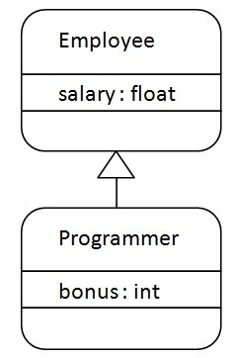

As displayed in the above figure, Programmer is the subclass and Employee is the superclass. The relationship between the two classes is **Programmer IS-A Employee**. It means that Programmer is a type of Employee.

class Employee{

 float salary=40000;

}

class Programmer extends Employee{

 int bonus=10000;

 public static void main(String args[]){

   Programmer p=new Programmer();

   System.out.println("Programmer salary is:"+p.salary);

   System.out.println("Bonus of Programmer is:"+p.bonus);

}

}

[Test it Now](https://www.javatpoint.com/opr/test.jsp?filename=Programmer)

Programmer salary is:40000.0

Bonus of programmer is:10000

## Types of inheritance in java

On the basis of class, there can be three types of inheritance in java: single, multilevel and hierarchical.

In java programming, multiple and hybrid inheritance is supported through interface only. We will learn about interfaces later.

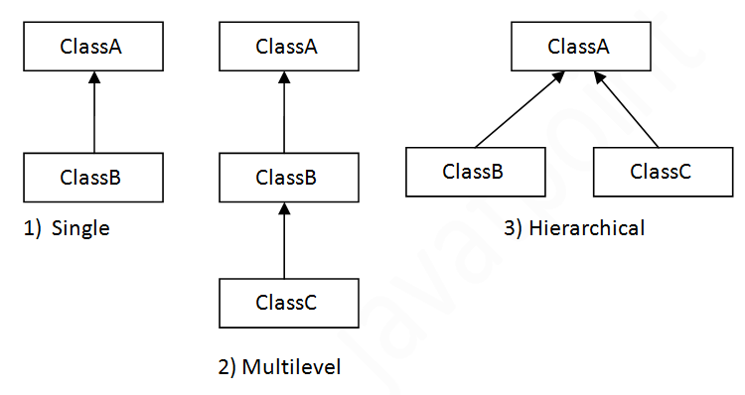

ckward 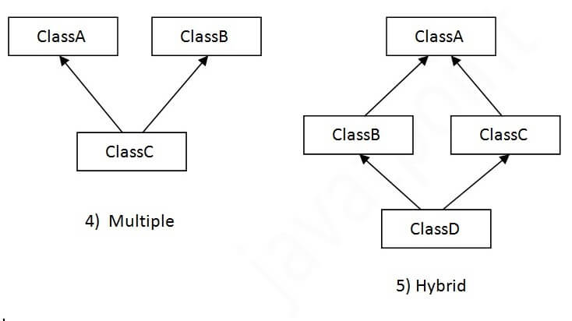

## Single Inheritance Example

When a class inherits another class, it is known as a single inheritance. In the example given below, Dog class inherits the Animal class, so there is the single inheritance.

*File: TestInheritance.java*

class Animal{

void eat(){System.out.println("eating...");}

}

class Dog extends Animal{

void bark(){System.out.println("barking...");}

}

class TestInheritance{

public static void main(String args[]){

Dog d=new Dog();

d.bark();

d.eat();

}}

Output:

barking...

eating...

## Multilevel Inheritance Example

When there is a chain of inheritance, it is known as multilevel inheritance. As you can see in the example given below, BabyDog class inherits the Dog class which again inherits the Animal class, so there is a multilevel inheritance.

*File: TestInheritance2.java*

class Animal{

void eat(){System.out.println("eating...");}

}

class Dog extends Animal{

void bark(){System.out.println("barking...");}

}

class BabyDog extends Dog{

void weep(){System.out.println("weeping...");}

}

class TestInheritance2{

public static void main(String args[]){

BabyDog d=new BabyDog();

d.weep();

d.bark();

d.eat();

}}

Output:

weeping...

barking...

eating...

## Hierarchical Inheritance Example

When two or more classes inherits a single class, it is known as hierarchical inheritance. In the example given below, Dog and Cat classes inherits the Animal class, so there is hierarchical inheritance.

*File: TestInheritance3.java*

class Animal{

void eat(){System.out.println("eating...");}

}

class Dog extends Animal{

void bark(){System.out.println("barking...");}

}

class Cat extends Animal{

void meow(){System.out.println("meowing...");}

}

class TestInheritance3{

public static void main(String args[]){

Cat c=new Cat();

c.meow();

c.eat();

//c.bark();//C.T.Error

}}

Output:

meowing...

eating...

## Q) Why multiple inheritance is not supported in java?

To reduce the complexity and simplify the language, multiple inheritance is not supported in java.

Consider a scenario where A, B, and C are three classes. The C class inherits A and B classes. If A and B classes have the same method and you call it from child class object, there will be ambiguity to call the method of A or B class.

Since compile-time errors are better than runtime errors, Java renders compile-time error if you inherit 2 classes. So whether you have same method or different, there will be compile time error.

class A{

void msg(){System.out.println("Hello");}

}

class B{

void msg(){System.out.println("Welcome");}

}

class C extends A,B{//suppose if it were

 public static void main(String args[]){

   C obj=new C();

   obj.msg();//Now which msg() method would be invoked?

}

}

Skip 10sPlay Video